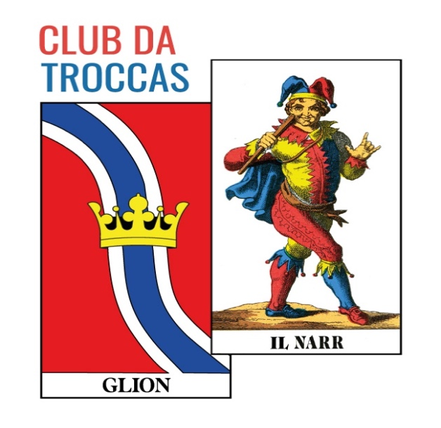

Club da troccas Glion
Maraton 13.09.2025 / Hotel Rätia, Glion
Rangaziun finala
Rang | Nums giugadurs
1 | Cadruvi Sep / Demont Remo
2 | Gautschi Urs / Janka Lucas
3 | Giossi Wendelin / Monn Stanis
4 | Carigiet Norbert / Montalta Peter
5 | Camathias Sebastian / Dermont Vitus
6 | Marty Paul / Monn Vrena
7 | Cathomas Renata / Diethelm Helena
8 | Caduff Reto / Casanova Christian
9 | Bearth Stefania / Beer Linus 21 / + 122
10 | Collenberg Giusep / Gartmann Paula 18 / + 29
11 | Tschuor Marcus / Tschuor Roman 18 / -39
12 | Cadruvi Meinrad / Vincenz Alfred 18 / -50
13 | Candinas Mattias / Maissen Jannette 14 / -151
14 | Casanova Pia / Schwörer Fritz 13 / -152
15 | Büchler Beatrice / Kaib Susanne 12 / -146
16 | Blumenthal Pia / Berther Lucrezia 8 / -279

